# Restaurant Management And Table Reservation

A Mini Project Report submitted to Chaitanya Deemed to be University in partial fulfillment of minimum academic requirements for

## BACHELOR OF TECHNOLOGY

**COMPUTER SCIENCE AND ENGINEERING**

**Submitted By**

**VYSHNAVI THIRUNAGARI (221022032)**

**DHEERAJ KUMAR MAHANKALI (221022033)**

**ISHANTH REDDY BETHELLI (221202034)**

**RAKSHITHA GUNDARAPU (221202039)**

**Under the guidance of**

**Dr. E. ARAVIND (Assoc. Professor)**

**DEPARTMENTOFCOMPUTER SCIENCE AND ENGINEERING**

# FACULTY OF ENGINEERING, CHAITANYA DEEMED TO BE UNIVERSITY

**HANAMKONDA, WARANGAL - 506001**

Accredited by NAAC “B++” Grade

(Affiliated to Chaitanya deemed to be university)

(2023-2024)

# FACULTY OF ENGINEERING

**HANAMKONDA, WARANGAL - 506001**

**DEPARTMENT OF COMPUTER SCIENCE AND ENGINEERING**



**CERTIFICATE**

This is to certify that the industrial Training report entitled “**Restaurant Management And Table Reservation”** is being submitted by **VYSHNAVI THIRUNAGARI (221202032), DHEERAJ KUMAR MAHANKALI (221202033), ISHANTH REDDY BETHELLI (221202034), RAKSHITHA GUNDARAPU RAKSHITHA (221202039),** in the partial fulfillment of the requirements for the award of the degree of **Bachelor of Technology** in “**Computer Science and Engineering**” at the **Chaitanya (Deemed to be University)** during the academic year 2023-2024.

Name and Signature of Project Guide Name and Signature of HOD

(Dr. E. ARAVIND Assoc. Professor) (Dr. E. Aravind Assoc. Professor)

Name and Signature of Dean

(Prof. G. SHANKARLINGAM)

**Signature of External examiner with Date**

# ACKNOWLEDGEMENT

The success accomplished in this project would not have been possible, by timely help and guidance rendered by many people, we wish to express our sincere and heart felt gratitude to all those who have helped and guided us for the completion of the project.

We sincerely extend our thanks to **Dr. E. ARAVIND Head & Assoc. Professor**, Department of Computer Science and Engineering for giving us moral support, kind attention and valuable guidance to us through out this training work.

We would like to express our deep sense of gratitude to **Prof. G. SHANKARLINGAM**, **Dean**, Faculty of engineering, for providing the required facilities in the college campus.

We would also thank all the staff of department of electronics and communication engineering who has helped us directly or indirectly for the successful completion of the project.

Finally, we express our sincere thanks & gratitude to our family members & friends for their constant encouragement and moral support, which made the project successful.

**VYSHNAVI THIRUNAGARI (221202032)**

**DHEERAJ KUMAR MAHANKALI (221202033)**

**ISHANTH REDDY BETHELLI (221202034)**

**RAKSHITHA GUNDARAPU (221202039)**

s

# DECLARATION

We here submit that the mini project report entitled **“RESTAURANT MANAGEMENT AND TABLE RESERVATION”** is an original work done at **Faculty of engineering, Hanamkonda** under the valuable guidance of **Dr. E. Aravind, Department of Computer Science and Engineering,** in partial fulfillment of the requirement for the award of the degree of **Bachelor of Technology** in Computer Science and Engineering. We here by declare that this project report bears no resemblance to any other reports submitted at *Faculty of Engineering* or any other college affiliated to Chaitanya deemed to be University for the award of the degree.

**VYSHNAVI THIRUNAGARI (221202032)**

**DHEERAJ KUMAR MAHANKALI (221202033)**

**ISHANTH REDDY BETHELLI (221202034)**

**RAKSHITHA GUNDARAPU (221202039)**

**ABSTRACT**

The restaurant industry is constantly evolving to meet the demands of a fast-paced and dynamic market. In this context, our project focuses on developing a comprehensive Restaurant Table Reservation System (RTRS) to revolutionize the traditional dining experience. This project aims to address the challenges faced by both customers and restaurant staff in the reservation process, enhancing overall efficiency and customer satisfaction. The Restaurant Table Reservation System is designed to provide a seamless and user-friendly interface for customers to make reservations. Utilizing modern web and mobile technologies, the system offers an intuitive booking platform that allows users to browse restaurant availability, select preferred time slots, and even choose specific tables based on their preferences. This ensures a personalized and efficient reservation process for customers, reducing the likelihood of no-shows and minimizing waiting times.

On the restaurant side, the system integrates with the existing point-of-sale (POS) system, kitchen management, and staff scheduling tools. Real-time updates on table availability enable staff to optimize seating arrangements, accommodating walk-in customers while ensuring a smooth flow of reservations. The automated communication system notifies customers about reservation confirmations, reminders, and any changes in their booking status, enhancing communication and reducing the likelihood of misunderstandings. One of the key features of the system is its dynamic table management capabilities. The RTRS continuously updates table availability based on real-time factors such as reservation status, table turnover rates, and staff availability. This dynamic approach allows the restaurant to maximize seating capacity during peak hours, optimize staff allocation, and ultimately increase revenue.

**TABLE OF CONTENTS**

**CHAPTER-1**

**INTRODUCTION** 9

* 1. Background Information 9
  2. Problem statement 10
  3. Objectives of the project 10

**CHAPTER -2**

2.1 Project scope 11

**CHAPTER -3**

3.1 Project purpose 12

3.2 Advantages of proposed system 12

**CHAPTER -4**

**OVERALL DESCRPTION**

4.1 Product perspective 13

4.2 product function 14

4.3 User characteristics 14

4.4 Constrains 14

4.5 Assumptions and dependencies 14

**CHAPTER -5**

**SPECIFIC REQUIREMENTS** 15

5.1 External interface requirements 15

5.2 User interface requirements 15

5.3 Hardware interface requirements 16

5.4 Software interface requirements 17

5.5 Development tools 17

5.6 Communication interface requirements 17

**CHAPTER -6**

FUNCTIONAL REQURIMENTS 18

6.1 User/administer login 19

6.2 User/admin registration 20

6.3 Reservation details 20

6.4 Browsing and database 21

6.5 Menu 22

6.6 Application maintenance 23

**CHAPTER -7**

**FEASABILITY STUDY**

7.1 Introduction 24

7.2 What the system will do 24

7.3 Problem statement 25

7.4 Admin 25

**CHAPTER -8**

**METHODOLOGY** 26

8.1 Introduction 26

8.2 System development methodology 26

8.2.1 Activity diagram 27

**CHAPTER -9**

**PROTOTYPES** 28

9.1 Architecture diagram 28

9.2 Use case diagram 29-30

9.3 Sequence diagram 31

**CHAPTER -10**

**CODE**

10.1 Reservation code 32-39

**CHAPTER -11**

11.1 Conclusion 40

11.2 Reference 40

**CHAPTER-1**

**INTRODUCTION**

**1.1 BACKGROUND INFORMATION**

The internet has become a very important aspect of life today. More than 3 billion people of the world have an access to the internet, which is relatively 45% of the world population. This has increased from 778 million users in the past 15 years which is a great and rapid growth. The number of users is anticipated to reach 60% by the year 2020. With this in mind, the rate at which this large population is seeking to buy items is also on the rise, as many people are seeking advanced and ideal routes of trading services. Some people spend a lot of money on transportation, using a lot of time of which at the end of the road they might lack to get the desired items which they opted for.

It is open that most people are seeking to go for restaurants in most cities and towns, both locally and abroad, desperate if they might get a solution, or a right person to deliver a solution to them. These people end up settling at reserving the tables in any restaurant in advance so he couldn't end up with a unsatisfactory of not having availability of the tables in his desired restaurant.

On the other hand, there are legit restaurants and cafes where the quality of the dishes are extraordinary, but they do not meet for business because of the lack of advertising and lesser talk about their restaurant. This is a great frustration in deed!

This project shall handle this issue by creating an online platform where a user will be able to look at any available restaurant he desires to dine-in. user can check availability of the tables in any restaurant, he/she can watch the menus, offers of different restaurants available all over country.

**1.2 PROBLEM STATEMENT**

Efficiency and effectiveness are the main concern of every business including restaurants. Restaurant managers and diners go through a lot of stress in terms of food ordering and table reservation leading to errors in the ordering and reservation processes hence, affecting the whole performance of the restaurant business. I find it necessary to come up with an application that would enable people either order food or reserve a table at a restaurant in an efficient and convenient way. I therefore came up with the idea to design and implement an online restaurant reservation system to enable restaurants manage their food orders and table reservation so that people will not join very long queues before being served their meal at the restaurant.

This chapter will introduce the project concept, outline the general objectives as well as the specific objectives that will eventually lead to the development of the project and the scope of the project. The chapter will also outline the timeline for the development of the project; specifying when each developmental phase will start and end,

**1.3 Objectives of the project**

**1.3.1 General objective**

To develop an online restaurant table reservation system which will provide service of reserving tables on user desired time through our website.

**1.3.2 Specific objectives**

The Online restaurant table reservation system shall accomplish the following as way of achieving the major goal:

1. Create an online forum where users can reserve their table in any restaurant through the online system.

2. Create a panel where user can look at menus of different restaurants, reserve a table in any restaurant, can match for any nearby restaurants through our website.

3. To implement and test the workability of the newly developed system.

**CHAPTER-2**

**2.1 PROJECT SCOPE**

This system is designed as an online web-based application which shall be accessed by any device, either a computer, tablet, iPad, iPhone, mobile phone or PDAs.

This system is targeted to serve primarily my local town, then by more modification it shall serve the whole country where more business enterprises shall have access to the system and finally reach out to the entire globe.

The proposed system is a software solution for users to easily add and take orders. When the new orders come in, some general information about the new order will be inputted such as item from menu, the price of each item, table number, time and date. Restaurant order will be a good solution for faster communication between the client and the server.

The system is free from risk of possible file loss and will have backup files so that the important data's were safe. The system is also free from risk of being intercepted by unauthorized person because before gaining access in the system, it is required to log onto the system by entering username, and alphanumeric password.

**CHAPTER-3**

**3.1 PROJECT PURPOSE**

To overcome the limitations of above systems, we propose this integration of touch technology in restaurants based on android technology. It is a wireless food ordering system using android devices. Android devices, in the past few years, have reached the pinnacle of popularity and have revolutionized the use of mobile technology in the automation of routine task in wireless environment. Android is an open-source, Linux based operating system for mobile devices such as smart-phones and tablets. The promising future of Android market makes the concept of writing applications for android beneficial and worthwhile. As a remedy for the above mentioned systems, we propose a restaurant with a touch technology system. Our system aims at providing the following features:

Combining of Wireless technology and Android OS to automate food ordering process.

- Increasing customer happiness. This also reduces waste as when the wrong item is ordered, the food must be discarded.

- Allow the restaurant to operate faster.

- To minimize the flaws in conventional system by atomizing the working of a restaurant.

- To provide a mechanism for obtaining feedback from the customers and provide the restaurant a means of review of their service.

**3.2. Advantages of Proposed system**

i. No wastage of time.

ii. Convenience for customer

iii. No shortage of tables.

iv. Speed and efficiency of service is much better.

v. User friendly

**CHAPTER-4**

**OVERALL DESCRIPTION**

**4.1 PRODUCT PERSPECTIVE**

The product is a web based system implementing client-server model under the GNU general Public License. The following are the main features;

1. Cross platform support - it offers operation support for most of the known and commercial operating systems including windows operating system, X operating system, Linux operating system, android operating system, chrome operating system etc.
2. User accounts - this system allows the system users to create system accounts, view and update their profiles.
3. Users supported in the system - the system support quite a large number of users at one time.
4. Search - it is a local search engine based on finding key words.
5. Chat platform - the system allows the users and the seller of products to chat through an inbuilt chat platform feature.

**4.2 PRODUCT FUNCTION**

1. Enable the users to view the list of restaurants available near by or at their desired location.

2. Enable creation of accounts and logging in to the accounts

3. Enable users to logout of their accounts

4. Provide interface for the administrator to view the transactions, table available and regions to the system.

5. The restaurant management should also have accounts where they will receive the customer orders and respond to them.

**4.3 USER CHARACTERISTICS**

The system requires that the users be equipped with overall internet knowledge and the gadget accessing it. The administrator is expected to have more skills with the interface of the tech support system. The sellers should also have skills of well analyzing and navigating the internet usage and be able to handle customers who may not be so familiar with the internet.

**4.4 CONSTRAINS**

The choice of the database to use should be considered carefully, since there will be a lot of data traffic and the large amounts of data will also judge the database. A good database will yield speed querying of data.

The browser used should support HTML5 to satisfy user experience.

The device should be enabled with internet.

**4.5 ASSUMPTIONS AND DEPENDENCIES**

The system highly relies on browsers that support HTML5 sites, the users with older versions of browsers of incompatible ones will need to upgrade to the newer browser versions.

**CHAPTER -5**

**SPECIFIC REQUIREMENTS**

**5.1 EXTERNAL INTERFACE REQUIREMENT**

The application ought to be web based.

System feature should be improved for better execution.

**5.2 USER INTERFACE REQUIREMENT**

Simple Graphical user interface (GUI) for easy navigating through the program.

Easy to update profile and items.

Dynamically configurable interface.

Search functions.

Appealing to the eye through coloration and pictorial presentation.

**5.3 HARDWARE INTERFACE REQUIREMENT**

Processor: 13 or above

Hard Disc: above 50GB

Ram:1GB or above

Free storage memory capacity of more than 100mb.

**5.4 SOFTWARE REQUIREMENT**

**Programming Languages:**

1. HTML (Hypertext Markup Language): Used for creating the structure and content of web pages.

2. CSS (Cascading Style Sheets): Used for styling the visual presentation of web pages.

3. JavaScript: Used for adding interactivity and dynamic behavior to web pages.

4. PHP (Hypertext Preprocessor): Used for server-side scripting to interact with databases and process user input.

**Database Management System:**

**1. MySQL:** Used as the relational database management system (RDBMS) for storing and managing reservation data, table availability, user information, and other relevant data.

**Web Server:**

1. Apache HTTP Server: Used as the web server software to host and serve the web application to clients.

**Development Tools:**

**1.** **Integrated Development Environment (IDE):** A development environment such as Visual Studio Code, Sublime Text, or Php Storm for writing, editing, and debugging code.

**2. MySQL Workbench:** A visual database design and administration tool for creating, managing, and querying MySQL databases.

**3. Version Control System:** Git for version control and collaboration among team members.

**4. Browser Compatibility:** Ensure compatibility with popular web browsers such as Google Chrome, Mozilla Firefox, Microsoft Edge, and Safari.

**Additional Libraries and Frameworks:**

**1. Bootstrap:** Front-end framework for building responsive and mobile-first websites.

**2. jQuery**: JavaScript library for simplifying client-side scripting tasks and handling events.

**3. AJAX (Asynchronous JavaScript and XML):** Used for making asynchronous HTTP requests to the server to update parts of a web page without reloading the entire page.

**4. PHP Data Objects (PDO):** PHP extension for accessing databases in a uniform and secure way, providing data access abstraction and protection against SQL injection attacks.

**Deployment Environment:**

**1. Operating System:** The web application can be deployed on a server running Linux, Windows, or macOS.

**2. Web Hosting Service**: A web hosting provider such as Amazon Web Services (AWS), Digital Ocean, or Google Cloud Platform for hosting the application online.

**Security Considerations:**

**1. Secure Socket Layer (SSL) Certificate**: To encrypt data transmitted between the web server and clients over HTTPS.

**2. Input Validation and Sanitization:** Implement proper input validation and sanitization techniques to prevent SQL injection, cross-site scripting (XSS), and other security vulnerabilities.

**3. Authentication and Authorization:** Implement secure authentication and authorization mechanisms to control access to sensitive areas of the application and protect user data.

**5.5DEVELOPMENT TOOLS**

1. MySQL database

2. Visual Studio IDE

3. Entity framework

4.source tree

5. Git Hub

**5.6 COMMUNICATION INTERFACE REQUIREMENT**

Internet connectivity

**CHAPTER-6**

**FUNCTIONAL REQUIREMENTS**

Functional requirements for the online restaurant table reservation management system have been developed to make sure that the functionalities and functional aspects of the system are met.

**Login:**

FR1. System will allow the user to login.

FR3. System will verify the user name and password.

FR4. System will not allow user to login with invalid username or password.

FR5. System will be able to remember username and password.

**Registration or create account:**

FR6. System will allow users to create account.

**Browsing and database search:**

FR7. System will allow user to search restaurants that are available in the website.

FR8. System shall display the result.

FR9. System will allow the user to reserve the table in desired restaurant.

**Table reservation:**

FR10. System will allow users to view the available restaurants in his/her desired city/town.

FR11. System will allow users view the available tables at his desired restaurant.

FR12. System will allow user to view the menu of any restaurant available.

**Purchase History:**

FR13. System will allow the user to view the details of the reservation of table.

**6.1 USER / ADMINISTER LOGIN**

The user interface and the source code for this requirement have been finished. The unit testing and functional testing activities need to be done.

The user/administer will be log-in to the system.

**FIGURE 1: LOGIN PROCESS**

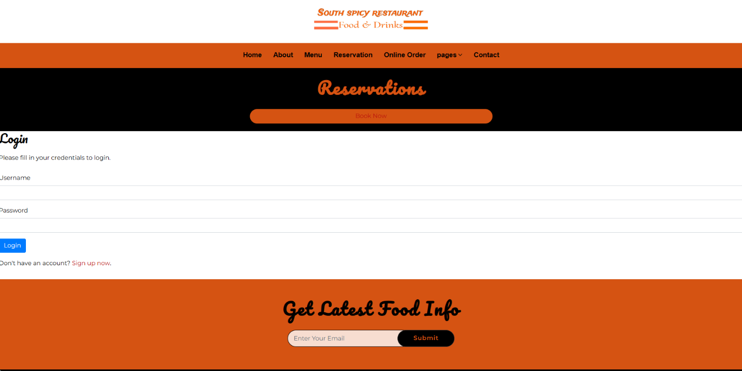

**6.2USER/ADMIN REGISTRATION**

In case of the absence of the user id and password, the user will be able to register themselves in the system. The user interface and the source code for this requirement have to be finished.

**FIGURE.2: CUSTOMER ACCOUNT REGISTRATION PROCESS**

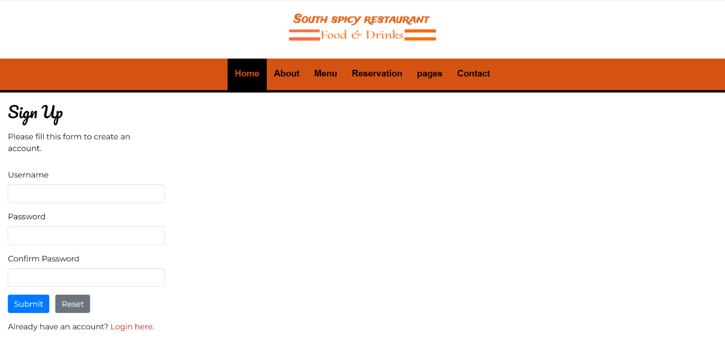

**6.3 Reservation details**

User after selecting the desired restaurant will be directed to this page where user can reserve the date and time to check the available table at the desired.

**FIGURE.3:RESERVATION DETAILS PROCESS**

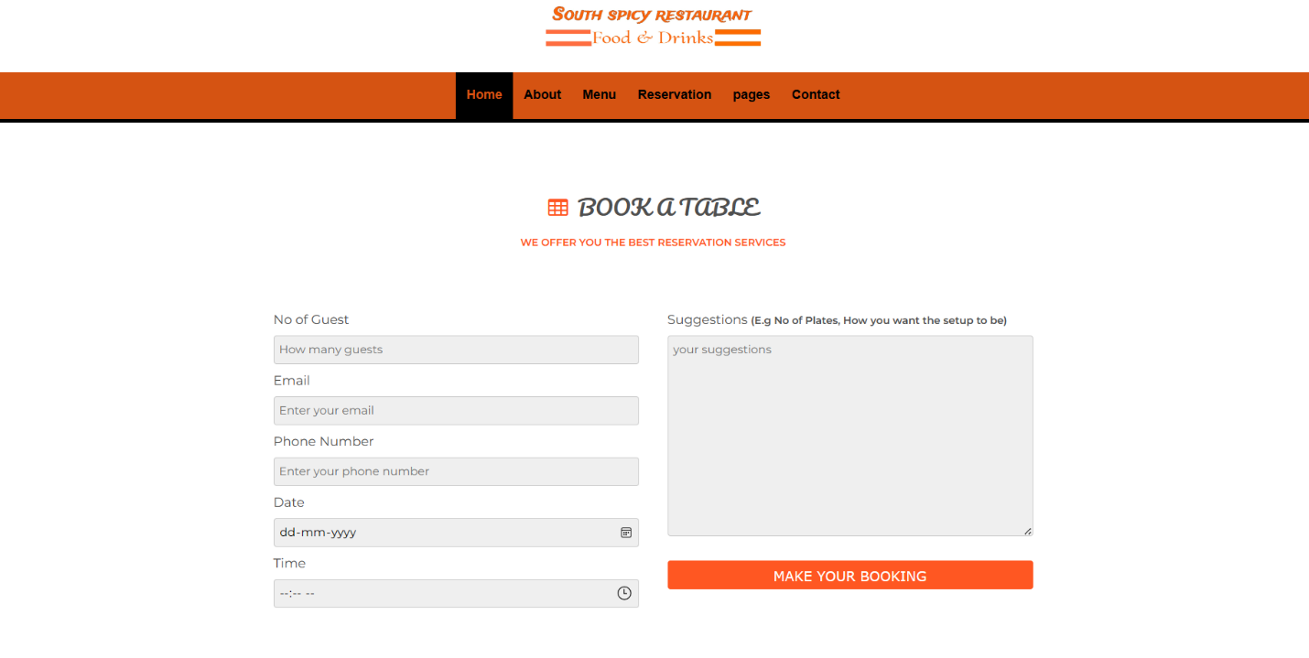

**6.4 Browsing and Database**

After reservation successful message will be displayed on the screen.

**FIGURE.4:RESERVATION CONFORMATION MESSAGE**

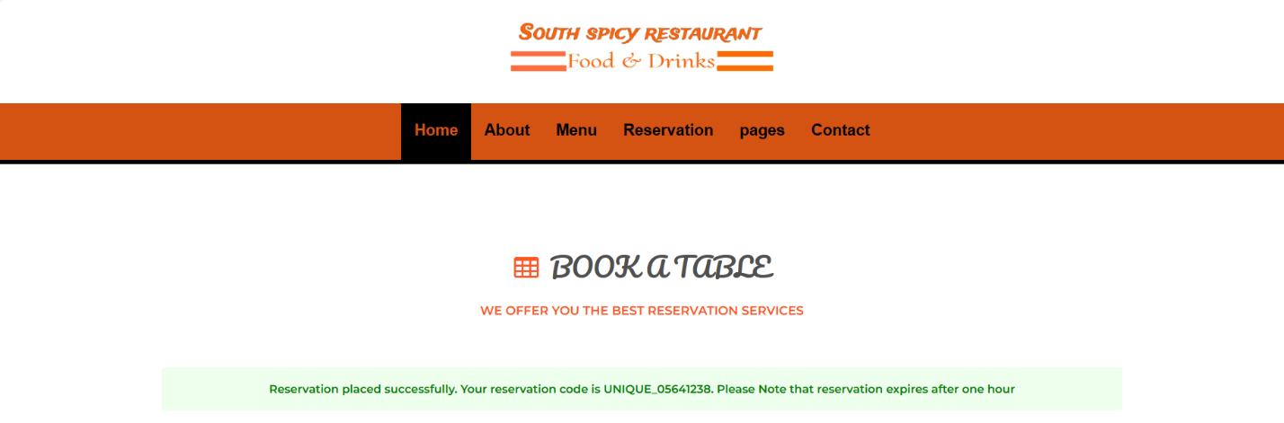

**FIGURE 5: DATA BASE RESERVATION DETAILS**

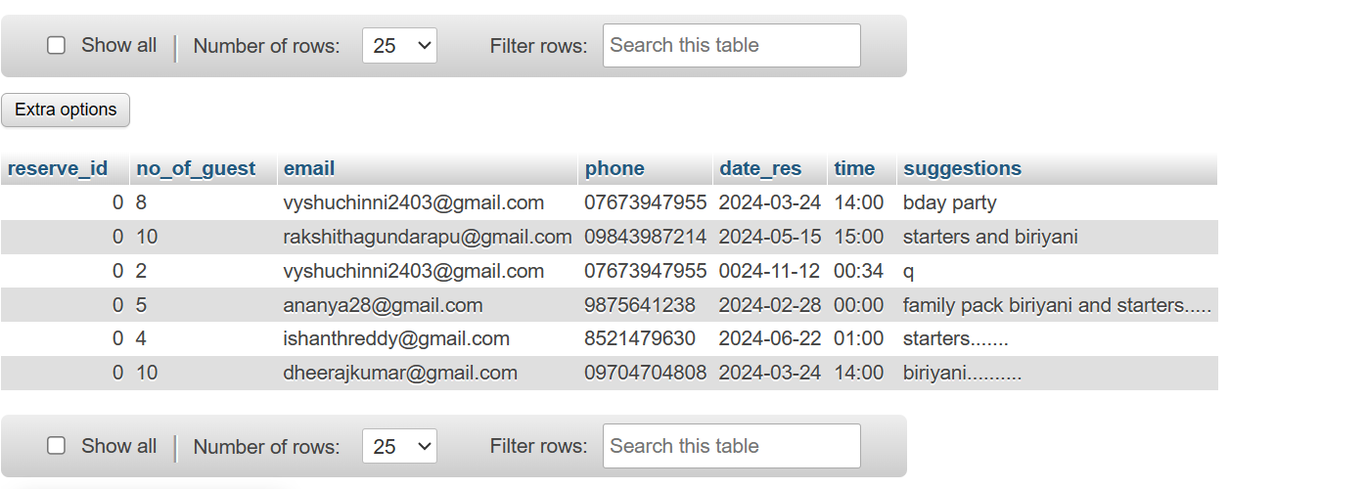

**6.5 FIGURE 6: MENU**

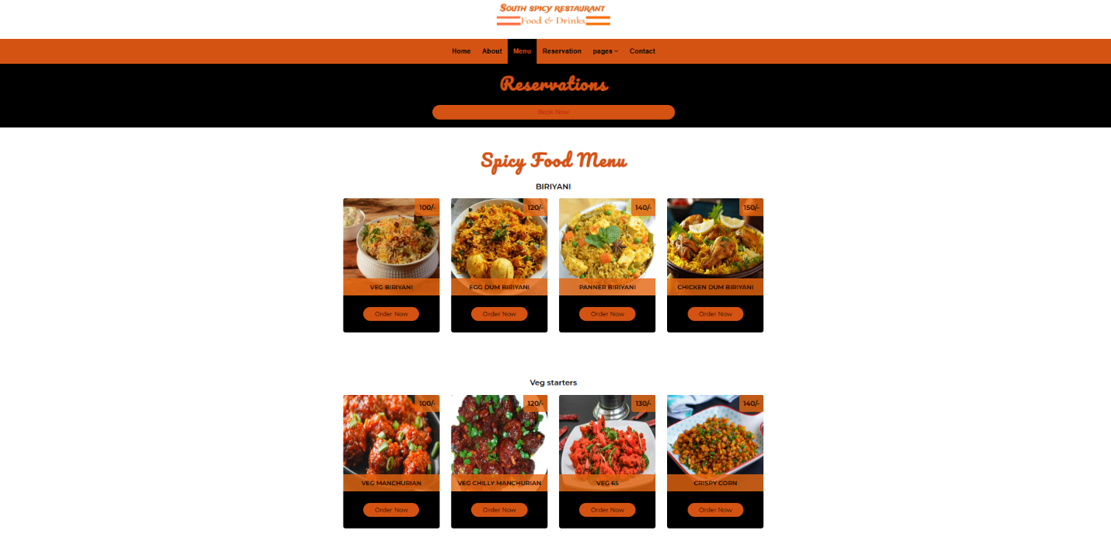

**6.6 APPLICATION MAINTENANCE**

Progress: The installation of the updates and patches along with the maintenance of the website. It is an ongoing requirement that will continue even after the release of the website.

|  |  |
| --- | --- |
| REQUIREMENTS | DESCRIPTION |
| Customer/administer login and new registration. | Customer/administer sign in, sign up, forgot password. |
| Browsing, database search. | User can browse the available restaurant in his desired city. |
| Reservation details. | Details of date and time to reserve table |
| List of tables. | Choosing the available tables in the restaurant |
| Application maintenance. | The admin will manage the application quality. |
|  |  |

**WEBSITE DESCRIPTION**

**FIGURE 7: CONTACT DETAILS**

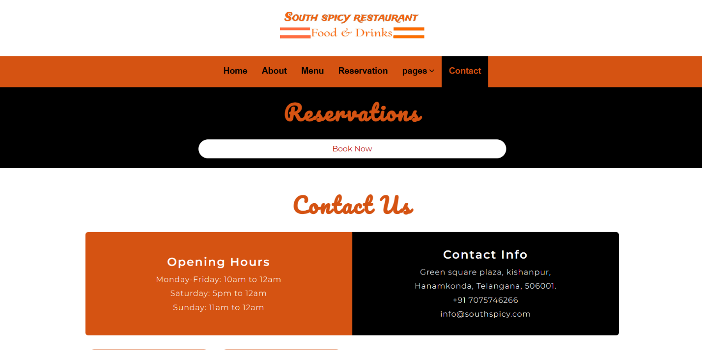

**CHAPTER-7**

**FEASABILITY STUDY**

**7.1 INTRODUCTION**

This project is an online platform where a user will be able reserve the table in a restaurant for dine-ins. My main aim is to address some of the shortfalls of the existing systems and to provide a more robust and reliable service for restaurant industry. The system will ensure the following:

Provide a system that would be used by a single vendor due to the time constraints needed to finish this project. The advantage here is that the restaurant has the flexibility to customize the system to suit the needs of its business.

Provide a platform for restaurant industry in Ghana to go global so that they can increase their patronage by consumers. This has an added advantage of increasing the revenues of the restaurant industries in Ghana that use my system.

Provide platform for food vendors to get their monies before successful order is placed. In this part of our world, if people do not pay before the order is placed, some might end up not showing up for their orders and the restaurant may incur debt. I hope to employ a mobile money payment platform to enable customers pay before their orders are placed successfully.

Provide a platform whereby customers can order food and also reserve tables at the same time which is not available in the ones highlighted above. In this case, with the same vendor, one can reserve a table or order food.

**7.2 WHAT THE SYSTEM WILL DO**

As stated earlier, customers basically reserve tables by means of their PCs mobile devices as well as other portable devices such as tablets. Customers order food using computers via browsers like Mozilla Firefox or via custom apps. This basically is the main trend with regards to food ordering and table reservation in the restaurant industry. In spite of consumer demand, restaurants' use of technology remains in its infancy hence, the use of technology in the restaurant industry is expected to gain dominance and recognition in the future.

This system will run on the internet since of the dynamic nature of the internet, and anybody can access it from smartphones, computers, personal digital assistants and many more digital gadgets. This is a sure promise that the system will serve many people in the country, and in the future it will reach out to the whole world.

The system is a forum where the customers are able reserve the tables for their dine-ins in any restaurant online and the restaurant management can avail their tables in our website for customers.

**7.3 PROBLEM STATEMENT**

Customers when arrived to the restaurant to only know that the tables aren't empty makes them feel bad of this. Customers will have to make long queues before placing their orders especially during peak hours and then the ordering staff will record customer orders. Having placed the order, the customer then have to wait near the counter until their order is ready to collect. The other problem in the food service industry is that restaurants are not realizing the efficiencies that would result from better application of technology in their daily operations.

**7.4 ADMIN**

* Login Page
* Home Page
* Menu page
* Reservation page
* Pages
* about

**CHAPTER 8**

**METHODOLOGY**

**8.1 INTRODUCTION**

In order to achieve the objectives of coming up with the online restaurant table reservation management system, the preliminary investigation about the workability of the software is necessary and need to be carried out first. This will equip us with the relevant materials and knowledge on how to carry out the implementation.

**8.2 SYSTEM DEVELOPMENT METHODOLOGY**

**8.2.1 ACTIVITY DIAGRAM**

Activity diagram provides a graphical representation of various activities that are carried out in an application. A clear overview of the online restaurant table reservation management website will be provided from the beginning till the end. The workflow of the activities and their dependencies with each other during the execution of the tasks and processes is shown in the activity diagram. The major functionalities of the site have been depicted using the diagram as shown below.

**NEW USER REGISTRATION**

**FIGURE:USER REGISTRATION**

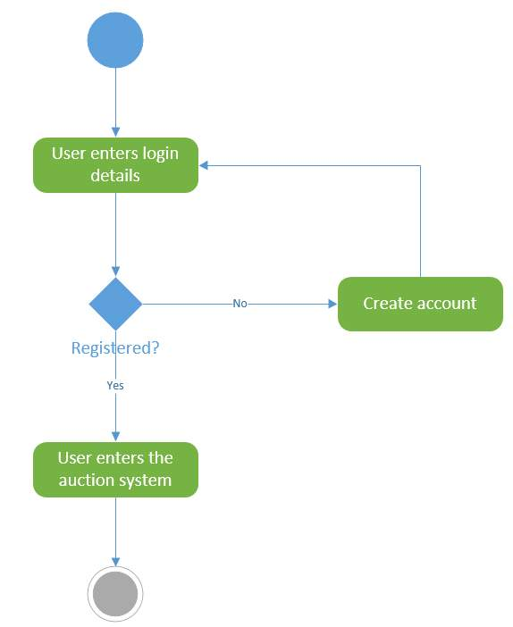

**RESERVATION PROCESS**

|  |
| --- |
|  |
| User visits the website for registration |
| ↆ |
| User then goes to login using I’D and password |
| ↆ |
| The system then validates the user |
| ↆ |
| User selects the ideal timing and date |
| ↆ |
| Then user proceeds for booking |
| ↆ |
| User gets the confirmation message |
|  |
|  |
|  |

**CHAPTER-9**

**PROTOTYPES**

**9.1. ARCHITECTURE DIAGRAM**

**FROM CUSTOMER’S PERCPECTIVE**

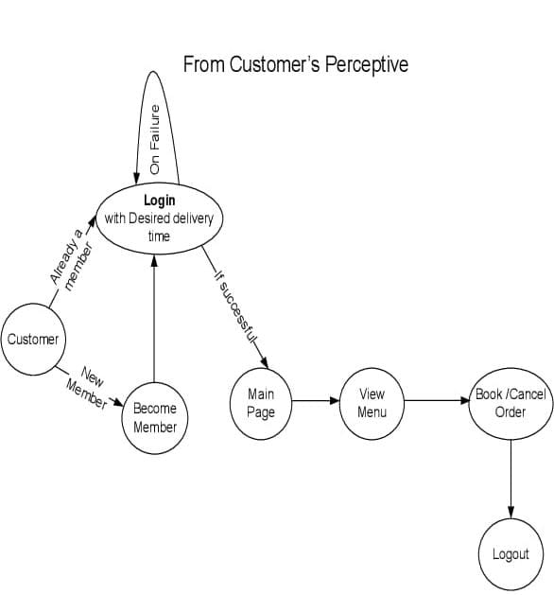

**FROM MANAGEMENT’S PERCPECTIVE**

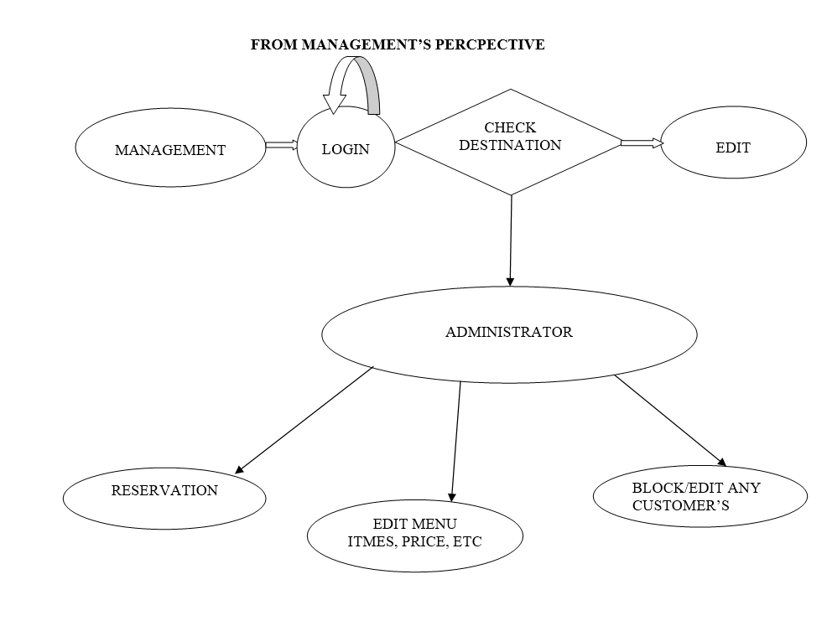

**9.2. USE CASE DIAGRAMS**

It is extremely significant to understand the needs of the user in a project. Use case diagram assists in defining the user requirements and needs. It also shows the interaction between the system users and the system itself which allows easier designing and development activities. The users for online restaurant table reservation management web site will be customer, restaurant staff or admin. The actors involved in the use case diagram will be the system, customer, restaurant staff, or admin. They will perform the various activities as illustrated in the functional requirements section.

**Restaurant System - Use Case Diagram**

**9.3 SEQUENCE DIAGRAM**

Sequence diagram is graphical representation of the whole system, that how the customer and admin will login. How the user will choose the restaurant and reserve the table to desired timing. The result will go to the restaurant staff/admin, then it will return back with the result. After the order confirmation admin updates the status of order.

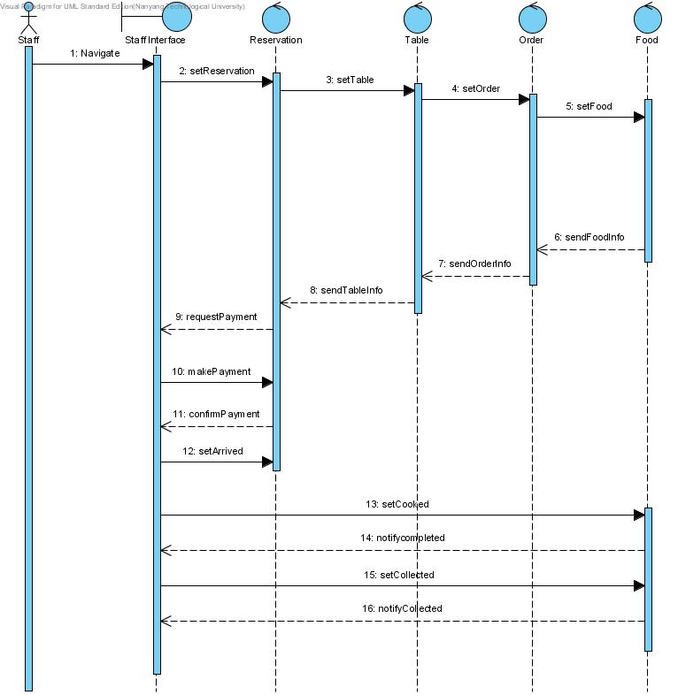

**Figure: sequence diagram**

**CHAPTER-10**

**SAMPLE CODE**

**RESERVATION CODE:**

<?php

session_start();

require "admin/functions.php";

require "admin/db.php";

$msg = "";

if($_SERVER['REQUEST_METHOD'] == 'POST') {

if(isset($_POST['submit'])) {

$guest = preg_replace("#[^0-9]#", "", $_POST['guest']);

$email = filter_var($_POST['email'], FILTER_VALIDATE_EMAIL);

$phone = preg_replace("#[^0-9]#", "", $_POST['phone']);

$date_res = htmlentities($_POST['date_res'], ENT_QUOTES, 'UTF-8');

$time = htmlentities($_POST['time'], ENT_QUOTES, 'UTF-8');

$suggestions = htmlentities($_POST['suggestions'], ENT_QUOTES, 'UTF-8');

if($guest != "" && $email && $phone != "" && $date_res != "" && $time != "" && $suggestions != "") {

$check = $db->query("SELECT * FROM reservation WHERE no_of_guest='".$guest."' AND email='".$email."' AND phone='".$phone."' AND date_res='".$date_res."' AND time='".$time."' LIMIT 1");

if($check->num_rows) {

$msg = "<p style='padding: 15px; color: red; background: #ffeeee; font-weight: bold; font-size: 13px; border-radius: 4px; text-align: center;'>You have already placed a reservation with the same information</p>";

}else{

$insert = $db->query("INSERT INTO reservation(no_of_guest, email, phone, date_res, time, suggestions) VALUES('".$guest."', '".$email."', '".$phone."', '".$date_res."', '".$time."', '".$suggestions."')");

if($insert) {

$ins_id = $db->insert_id;

$reserve_code = "UNIQUE_$ins_id".substr($phone, 3, 8);

$msg = "<p style='padding: 15px; color: green; background: #eeffee; font-weight: bold; font-size: 13px; border-radius: 4px; text-align: center;'>Reservation placed successfully. Your reservation code is $reserve_code. Please Note that reservation expires after one hour</p>";

}else{

$msg = "<p style='padding: 15px; color: red; background: #ffeeee; font-weight: bold; font-size: 13px; border-radius: 4px; text-align: center;'>Could not place reservation. Please try again</p>";

}

}

}else{

$msg = "<p style='padding: 15px; color: red; background: #ffeeee; font-weight: bold; font-size: 13px; border-radius: 4px; text-align: center;'>Incomplete form data or Invalid data type</p>";

print_r($_POST);

}

}

}

?>

<!Doctype html>

<html lang="en">

<meta name="viewport" content="width=device-width, initial-scale=1.0" />

<meta name="description" content="" />

<meta name="keywords" content="" />

<head>

<title>reservation</title>

<link rel="stylesheet" href="css/main.css" />

<script src="js/jquery.min.js" ></script>

<script src="js/myscript.js"></script>

<!-- Favicons -->

<link href="img/favicon.ico" rel="icon">

<link href="img/apple-touch-icon.png" rel="apple-touch-icon">

<!-- Google Fonts -->

<link href="https://fonts.googleapis.com/css?family=Montserrat:200,300,400,500,600|Pacifico" rel="stylesheet">

<!-- Bootstrap CSS File -->

<link href="vendor/bootstrap/css/bootstrap.min.css" rel="stylesheet">

<!-- Libraries CSS Files -->

<link href="vendor/font-awesome/css/font-awesome.min.css" rel="stylesheet">

<link href="vendor/animate/animate.min.css" rel="stylesheet">

<link href="vendor/owlcarousel/assets/owl.carousel.min.css" rel="stylesheet">

<link href="vendor/tempusdominus/css/tempusdominus-bootstrap-4.min.css" rel="stylesheet" />

<!-- Main Stylesheet File -->

<link href="css/style.css" rel="stylesheet">

</head>

<body>

<!-- Top Header Start -->

<section id="top-header">

<div class="logo">

<img src="img/logo.jpg.jpeg" />

</div>

</section>

<!-- Top Header End -->

<!-- Header Start -->

<header id="header">

<div class="container">

<nav id="nav-menu-container">

<ul class="nav-menu">

<li class="menu-active"><a href="index.html">Home</a></li>

<li><a href="about.html">About</a></li>

<li><a href="menu.html">Menu</a></li>

<li><a href="reservation.php">Reservation</a></li>

<li class="menu-has-children"><a href="#">pages</a>

<ul>

<li><a href="log_in.php">Login</a></li>

</ul>

</li>

<li><a href="contact.html">Contact</a></li>

</ul>

</nav>

</div>

</header>

<!-- Header End -->

<div class="content" onclick="remove_class()">

<div class="inner_content">

<form method="post" action="<?php echo $_SERVER['PHP_SELF']; ?>" class="hr_book_form">

<h2 class="form_head"><span class="book_icon">BOOK A TABLE</span></h2>

<p class="form_slg">We offer you the best reservation services</p>

<?php echo "<br/>".$msg; ?>

<div class="left">

<div class="form_group">

<label>No of Guest</label>

<input type="number" placeholder="How many guests" min="1" name="guest" id="guest" required>

</div>

<div class="form_group">

<label>Email</label>

<input type="email" name="email" placeholder="Enter your email" required>

</div>

<div class="form_group">

<label>Phone Number</label>

<input type="text" name="phone" placeholder="Enter your phone number" required>

</div>

<div class="form_group">

<label>Date</label>

<input type="date" name="date_res" placeholder="Select date for booking" required>

</div>

<div class="form_group">

<label>Time</label>

<input type="time" name="time" placeholder="Select time for booking" required>

</div>

</div>

<div class="left">

<div class="form_group">

<label>Suggestions <small><b>(E.g No of Plates, How you want the setup to be)</b></small></label>

<textarea name="suggestions" placeholder="your suggestions" required></textarea>

</div>

<div class="form_group">

<input type="submit" class="submit" name="submit" value="MAKE YOUR BOOKING" />

</div>

</div>

<p class="clear"></p>

</form>

</div>

</div>

</body>

</html>

**CHAPTER-11**

**CONCLUSION:**

In conclusion, the Restaurant Table Reservation System has successfully revolutionized the way restaurants manage table reservations, enhancing the dining experience for both customers and staff. With streamlined reservation processes, efficient management tools, and automated notifications, the system has significantly improved operational efficiency and customer satisfaction. Through meticulous development and continuous refinement, we have delivered a robust and user-friendly platform that addresses the diverse needs of our stakeholders. Moving forward, ongoing maintenance and iteration will ensure the system remains relevant and effective in an ever-evolving industry landscape. The success of this project underscores the power of technology in transforming traditional processes and driving business growth. We are confident that our system will continue to make a positive impact on the hospitality sector, setting new standards for reservation management excellence.

**REFERENCES:**

➤ Dutta, R. and Ramamoorthy, K., International Business Machines Corp, 2009. User rating system for online table reservations

➤ Konia, B.S., MARKET MY SITE Inc, 2007. Online restaurant table reservation system and method

➤ Shavit, E. and Teichner, L., STRATEGIC PROCESSING CORP, 2011. Interactive market management system.